

**Assignment Cover Sheet**

|  |  |  |  |  |  |  |
| --- | --- | --- | --- | --- | --- | --- |
| **Student name:** | **Sarah Narayamy Tavares Silva** | | | | | |
| **Student number:** | **2960992** | | |  | | |
| **Faculty:** | **Computing Science** | | |  | | |
| **Course:** | **Computing Science** | | | **Stage/year:** | **3** | |
| **Subject:** | **Networks and Data Communications** | | | | | |
| **Study Mode:** | Full time | **X** |  | Part-time |  |  |
| **Lecturer Name:** | **Brendan Fogarty** | | | | | |
| **Assignment Title:** | **Tutorial Sheet 1** | | | | | |
| **No. of pages:** |  | | |  | | |
| **Disk included?** | Yes |  |  | No | **X** |  |
| **Additional Information:** | (ie. number of pieces submitted, size of assignment, A2, A3 etc) | | | | | |
|  | | | | | |
|  | | | | | |
| **Date due:** | **08/10/2019** | | |  | | |
| **Date submitted:** |  | | |  | | |
|  | | | | | | |
| **Plagiarism disclaimer:**  *I understand that plagiarism is a serious offence and have read and understood the college policy on plagiarism. I also understand that I may receive a mark of zero if I have not identified and properly attributed sources which have been used, referred to, or have in any way influenced the preparation of this assignment, or if I have knowingly allowed others to plagiarise my work in this way.*  *I hereby certify that this assignment is my own work, based on my personal study and/or research, and that I have acknowledged all material and sources used in its preparation. I also certify that the assignment has not previously been submitted for assessment and that I have not copied in part or whole or otherwise plagiarised the work of anyone else, including other students.*  **Signed: Sarah Narayamy Tavares Silva Date:** | | | | | | |

## **Please note:** Students **MUST** retain a hard / soft copy of **ALL** assignments as well as a receipt issued and signed by a member of Faculty as proof of submission.

Question 01: Network Fundamentals

Define the following network related terms:

1. Transmitter

A transmitter is an electronic device used to send a message from point A to point B.

1. Receiver

A receiver is an end device that receives a given message from a point A.

1. Message

Message is the information being exchanged, for example a HTTP request.

1. Transmission Medium

Transmission medium is the physical pathway over which the message travels.

1. Protocol

Protocol is the set of rules governing data communications (agreement) on how to transfer the data, ensuring how to package up the message and transfer it from point A to point B.

Question 2: Network Topologies

Using appropriate diagrams, describe the following topologies:

State in your answer two advantages and two disadvantages of each topology type

1. Bus

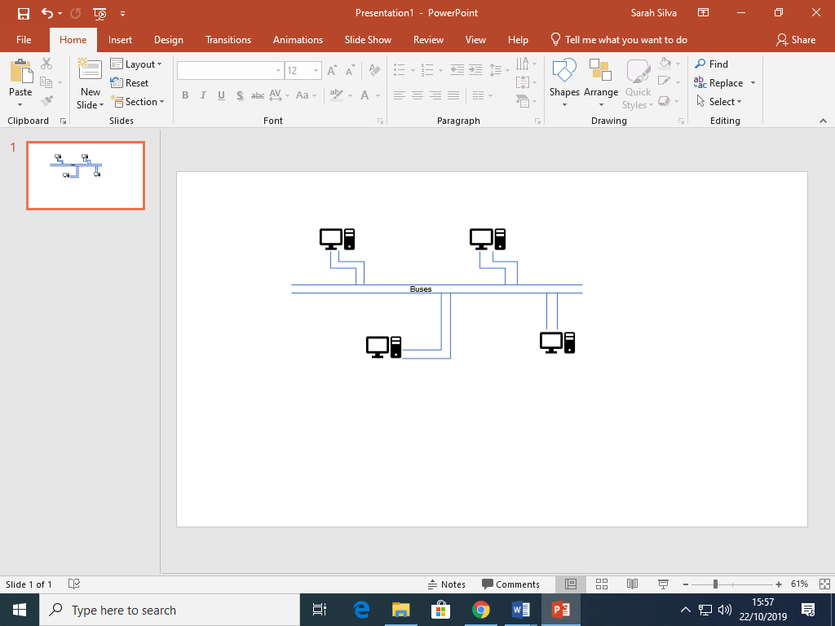

Bus Topology can also be called Line topology or backbone topology. It is characterized as having all the nodes or devices interconnected using a single cable, called bus. One of its advantages is that it is easy to set up and it is cheap, it is also easy to add or remove a node, but on the other hand; it has a single point of failure, which means that if the bus fails the whole network goes down. A second negative point is that it has slow data transfer rates.

1. Star

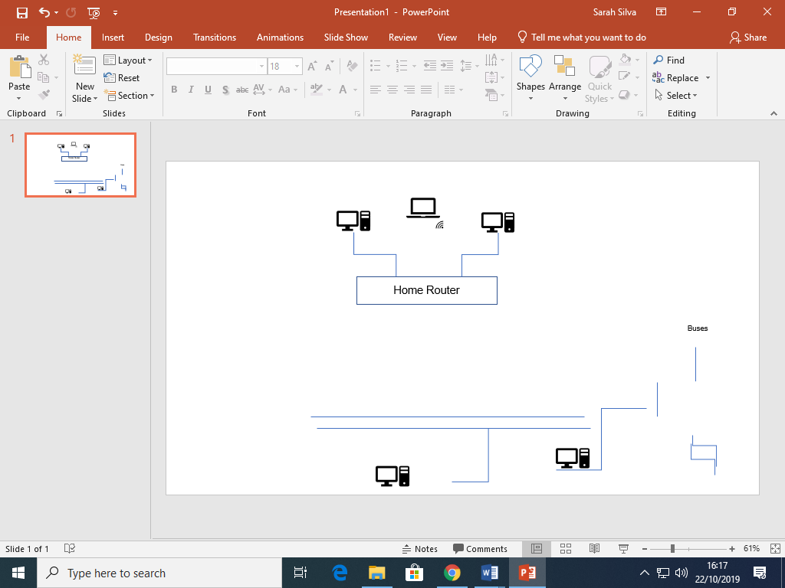

The Star topology is characterized as all the nodes or devices being connected to a central device (Home router), which takes care of the network. In addition to that, each node is also indirectly connected to the other nodes via the Home router. This topology is also easy to set up and easy to add and remove new nodes; in case of a failure on any of the nodes, this will not affect the rest of the network. The star topology has also a single point of failure as disadvantage, which is the central device (Home router), which means that if it goes down, the entire network crashes and the cost of the central device is high.

1. Full Mesh

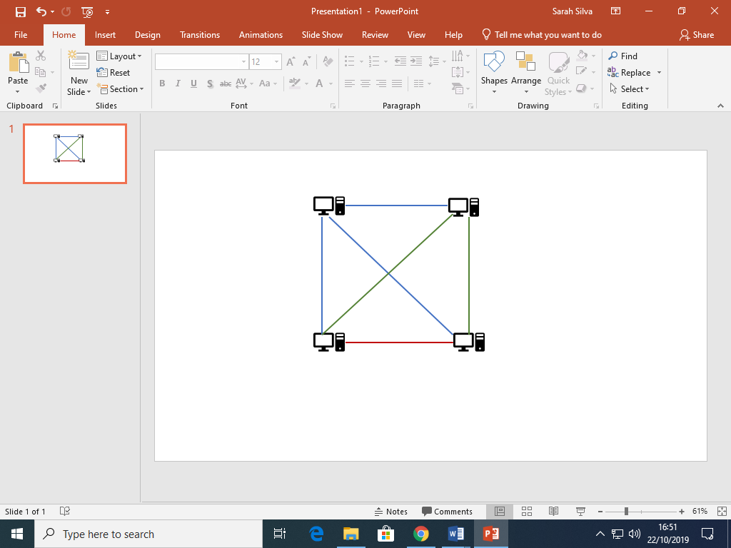

In Full mesh topology, all nodes are directly connected to all the other nodes. The message is routed sent, which means that the nodes use logic to find the shortest distance from point A to point B or flooded sent, which means that all nodes within the network receives the message without the need for routing logic. This topology is very reliable and there is no single point of failure, which means that even if one node failure the network can still work. One of its disadvantages is that it is very complex to install and a second disadvantage is the cost of it with wires and NIC’s.

Question 3: Guided Media

Compare Cat5 cabling and fibre optic cabling under the following headings:

1. Cable structure

Cat5 cables are also called Ethernet cable and it has a twisted pair structure which contains eight individual 24-gauge copper wires groped into four pairs inside the external layer. While fibre optic cables are made up of glass as its core, which make them very fragile.

1. Capacity
2. Maximum Data Rate (Speed)

Cat5 cables has a 100Mbps speed while fibre optic cables can reach Gbps speed, depending on if it is a single mode or a multimode fibre optic cable.

1. Signal propagation

Cat5 cables uses electricity to send a signal while fibre optic cables uses light-based technology, which converts electrical information into a series of light pulses.

1. Main area of usage

Question 4: Network Types

Using appropriate diagrams, discuss how LANs and WANs are different.

Note: *You must discuss a minimum of three differences.*

The term LANs stands for local area network which, as the name says, connects computer/ machines in a home, or a business, or a school for example. It can cover a single building or a group of buildings located close to one another (max of 1km). This type of network has a high speed feature of 1000 mbps and a high data transfer rate. Because they have a small number of system to deal with, LANs tend to have fewer problems associated with them and fewer data transmission errors. Usually they are privately owned. It is not expensive to add or remove extra device on the network also it has a relatively low cost maintenance due to covering a small geographical area.

The term WAN stands for Wide Area Network which means that the geographical area of coverage of the type of network could be a city, a country, a continent or even the world. The Internet is the best example of this network which connects networks with networks. The speed is low and a lower data transfer rate specially comparing to LANs, reaching 150 mbps. Since this network consists of a large number of systems, WANs tend to be less fault tolerant and experiences more data transmission errors. The complexity of this type of network is very high and so is the cost of it.

Question 5: Addressing 1

1. Compare IPv4 and Ipv6 addresses under four appropriate headings

IPV4 has a 32 bit address length while IPV6 addresses have 128 bits of length. The representation of an IPV4 address is in decimal while IPV6 is in hexadecimal. IPV4 addresses are displayed using dotted decimal notation while each 4 hexadecimal group in the IPV6 is separated by a colon “:”. IPV4 can generate only 4.29 x 109 addresses while IPV6 can produce 3.4 x 1038 addresses space.

1. Explain with the aid of a diagram how MAC Addresses facilitate node-to-node communication
2. State what a Port Address is and its purpose.

Question 6: Addressing 2

Using appropriate diagrams describe a Unicast, a Multicast and a Broadcast Address. State the purpose of each address type in your solution.

Question 7: Attenuation

With the aid of a diagram explain what attenuation is and how it is resolved

Question 8: Network Hardware

State the purpose of a switch and describe how a switch processes an incoming frame.

Question 9: Error Detection

Using examples differentiate between a single bit error and a burst error.

Question 10: DOS Prompt Commands

Issue the appropriate DOS Prompt command for each task below. Clearly

state the command used and include a screenshot of the output.

1. Determine the IP address on a Windows Machine
2. Determine your Wired/Wireless Adapter’s MAC address
3. Send an (ICMP) packet to a remote host such as bbc.com.
4. Resolve a domain (e.g. Griffith.ie) to its public IP address(es)